Wi-Fi Frame

📡 What Is a Wi-Fi Frame?
# Source: AI Source: Provided by: [Data Path: Persons Table -> ID Column: 1, Name_En Column: Motasem Essam] -> From: [ChatGPT] on [1/16/2026]
A Wi-Fi frame is a data structure used in wireless networks (IEEE 802.11) to organize, transmit, and manage data between wireless devices (like laptops, phones, and routers). It plays the same role as an Ethernet frame, but adapted for wireless communication, including security, mobility, and retransmission control.

🧠 Simple Definition:
# Source: AI Source: Provided by: [Data Path: Persons Table -> ID Column: 1, Name_En Column: Motasem Essam] -> From: [ChatGPT] on [1/16/2026]
A Wi-Fi frame is a wireless Layer 2 (Data Link Layer) frame used to carry data and control information over a Wi-Fi (802.11) network.

📦 General Structure of a Wi-Fi Frame
# Source: AI Source: Provided by: [Data Path: Persons Table -> ID Column: 1, Name_En Column: Motasem Essam] -> From: [ChatGPT] on [1/16/2026]
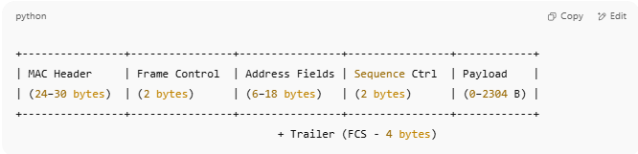
+----------------+----------------+----------------+----------------+------------+
| MAC Header | Frame Control | Address Fields | Sequence Ctrl | Payload |
| (24–30 bytes) | (2 bytes) | (6–18 bytes) | (2 bytes) | (0–2304 B) |
+----------------+----------------+----------------+----------------+------------+
+ Trailer (FCS - 4 bytes)

🔹 Key Components
# Source: AI Source: Provided by: [Data Path: Persons Table -> ID Column: 1, Name_En Column: Motasem Essam] -> From: [ChatGPT] on [1/16/2026]
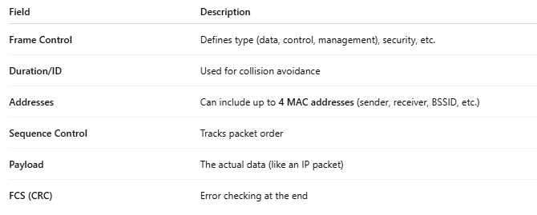
Field | Description
Frame Control | Defines type (data, control, management), security, etc.
Duration/ID | Used for collision avoidance
Addresses | Can include up to 4 MAC addresses (sender, receiver, BSSID, etc.)
Sequence Control | Tracks packet order
Payload | The actual data (like an IP packet)
FCS (CRC) | Error checking at the end

📂 Types of Wi-Fi Frames
# Source: AI Source: Provided by: [Data Path: Persons Table -> ID Column: 1, Name_En Column: Motasem Essam] -> From: [ChatGPT] on [1/16/2026]
Wi-Fi uses 3 main frame types:
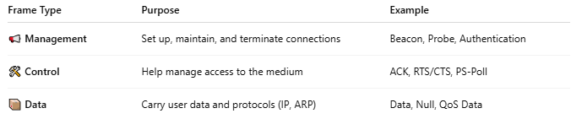
Frame Type | Purpose | Example
📢 Management | Set up, maintain, and terminate connections | Beacon, Probe, Authentication
🛠 Control | Help manage access to the medium | ACK, RTS/CTS, PS-Poll
📦 Data | Carry user data and protocols (IP, ARP) | Data, Null, QoS Data

🧾 Example: Data Frame Fields (Simplified)
# Source: AI Source: Provided by: [Data Path: Persons Table -> ID Column: 1, Name_En Column: Motasem Essam] -> From: [ChatGPT] on [1/16/2026]
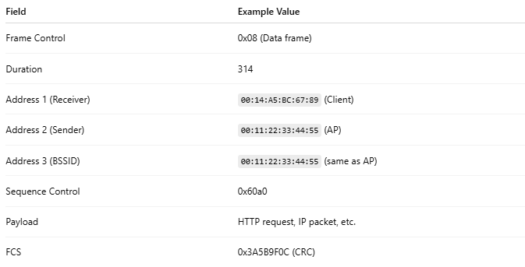
Field | Example Value
Frame Control | 0x08 (Data frame)
Duration | 314
Address 1 (Receiver) | 00:14:A5:BC:67:89 (Client)
Address 2 (Sender) | 00:11:22:33:44:55 (AP)
Address 3 (BSSID) | 00:11:22:33:44:55 (same as AP)
Sequence Control | 0x60a0
Payload | HTTP request, IP packet, etc.
FCS | 0x3A5B9F0C (CRC)

🧠 Visual Example – Wi-Fi Data Frame (802.11)
# Source: AI Source: Provided by: [Data Path: Persons Table -> ID Column: 1, Name_En Column: Motasem Essam] -> From: [ChatGPT] on [1/16/2026]
This is a simplified example of a data frame sent from an Access Point (AP) to a Wi-Fi client.
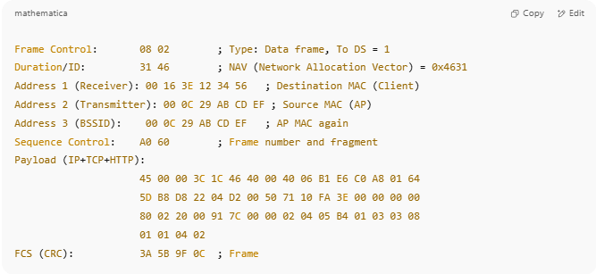
Frame Control: 08 02 ; Type: Data frame, To DS = 1
Duration/ID: 31 46 ; NAV (Network Allocation Vector) = 0x4631
Address 1 (Receiver): 00 16 3E 12 34 56 ; Destination MAC (Client)
Address 2 (Transmitter): 00 0C 29 AB CD EF ; Source MAC (AP)
Address 3 (BSSID): 00 0C 29 AB CD EF ; AP MAC again
Sequence Control: A0 60 ; Frame number and fragment
Payload (IP+TCP+HTTP):
45 00 00 3C 1C 46 40 00 40 06 B1 E6 C0 A8 01 64
5D B8 D8 22 04 D2 00 50 71 10 FA 3E 00 00 00 00
80 02 20 00 91 7C 00 00 02 04 05 B4 01 03 03 08
01 01 04 02
FCS (CRC): 3A 5B 9F 0C ; Frame Check Sequence

📄 Explanation of Fields:
# Source: AI Source: Provided by: [Data Path: Persons Table -> ID Column: 1, Name_En Column: Motasem Essam] -> From: [ChatGPT] on [1/16/2026]
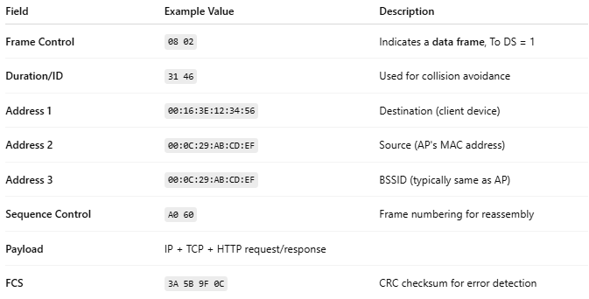
Field | Example Value | Description
Frame Control | 08 02 | Indicates a data frame, To DS = 1
Duration/ID | 31 46 | Used for collision avoidance
Address 1 | 00:16:3E:12:34:56 | Destination (client device)
Address 2 | 00:0C:29:AB:CD:EF | Source (AP's MAC address)
Address 3 | 00:0C:29:AB:CD:EF | BSSID (typically same as AP)
Sequence Control | A0 60 | Frame numbering for reassembly
Payload | IP + TCP + HTTP request/response
FCS | 3A 5B 9F 0C | CRC checksum for error detection

✅ Summary (Structure Overview)
# Source: AI Source: Provided by: [Data Path: Persons Table -> ID Column: 1, Name_En Column: Motasem Essam] -> From: [ChatGPT] on [1/16/2026]
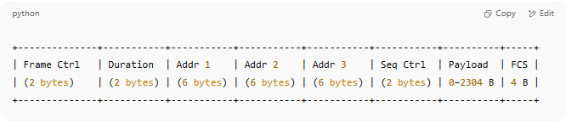
+--------------+-----------+-----------+-----------+-----------+-----------+----------+-----+
| Frame Ctrl | Duration | Addr 1 | Addr 2 | Addr 3 | Seq Ctrl | Payload | FCS |
| (2 bytes) | (2 bytes) | (6 bytes) | (6 bytes) | (6 bytes) | (2 bytes) | 0–2304 B | 4 B |
+--------------+-----------+-----------+-----------+-----------+-----------+----------+-----+

🆚 Wi-Fi Frame vs Ethernet Frame
# Source: AI Source: Provided by: [Data Path: Persons Table -> ID Column: 1, Name_En Column: Motasem Essam] -> From: [ChatGPT] on [1/16/2026]
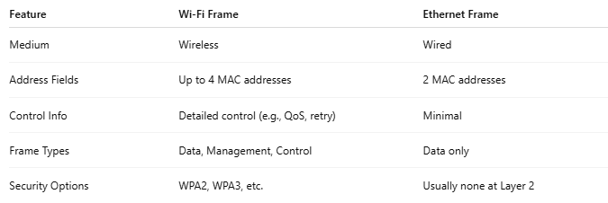
Feature | Wi-Fi Frame | Ethernet Frame
Medium | Wireless | Wired
Address Fields | Up to 4 MAC addresses | 2 MAC addresses
Control Info | Detailed control (e.g., QoS, retry) | Minimal
Frame Types | Data, Management, Control | Data only
Security Options | WPA2, WPA3, etc. | Usually none at Layer 2

📌 Summary
# Source: AI Source: Provided by: [Data Path: Persons Table -> ID Column: 1, Name_En Column: Motasem Essam] -> From: [ChatGPT] on [1/16/2026]
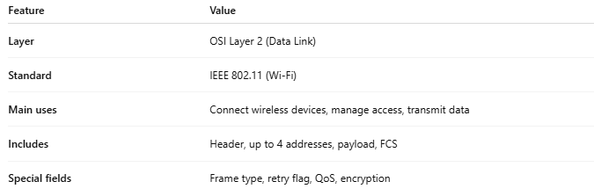
Feature | Value
Layer | OSI Layer 2 (Data Link)
Standard | IEEE 802.11 (Wi-Fi)
Main uses | Connect wireless devices, manage access, transmit data
Includes | Header, up to 4 addresses, payload, FCS
Special fields | Frame type, retry flag, QoS, encryption

